**SUBJECT NAME: Physics**

**Section: A**

**TOPIC NAME :** Mathematical Tool

**SUBTOPIC :**

Q 1] : Find the equation of line \[{{\ell }_{2}}\]passing from point A(4, 1)? 1

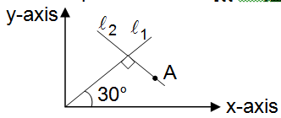

**OPTION A :** \[y=+\sqrt{3}x-4\sqrt{3}+1\]

**OPTION B :** \[y=-\sqrt{3}\,x+4\sqrt{3}+1\]

**OPTION C :** \[y=\frac{-\,x}{\sqrt{3}}-\frac{4}{\sqrt{3}}+1\]

**OPTION D :** \[y=\frac{-\,x}{\sqrt{3}}+\frac{4}{\sqrt{3}}+1\]

**CORRECT_OPTION :** 2

**SOLUTION :**

**CORRECT_ANSWER_FROM :**

**CORRECT_ANSWER_TO :**

**TOPIC NAME :** Units and Dimension

**SUBTOPIC :**

Q 2] : If an unknown quantity, \[\phi =\frac{ma}{\alpha }\log \left( 1+\frac{\alpha \,l}{ma} \right)\]. where, m = mass, a = acceleration and \[l=\]length The dimensions of \[\phi \] are 2

**OPTION A :** \[[M\,\,L\,\,{{T}^{-2}}]\]

**OPTION B :** \[[M\,\,{{T}^{-2}}]\]

**OPTION C :** \[[{{M}^{0}}\,L\,\,{{T}^{0}}]\]

**OPTION D :** \[[M\,\,{{L}^{-3}}]\]

**CORRECT_OPTION :** 3

**SOLUTION :**

**CORRECT_ANSWER_FROM :**

**CORRECT_ANSWER_TO :**

**TOPIC NAME :** Units and Dimension

**SUBTOPIC :**

Q 3] : Which of the following combinations of three dimensionally different physical quantities P, Q, R can never be a meaningful quantity? 3

**OPTION A :** PQ – R

**OPTION B :** PQ/R

**OPTION C :** (P – Q)/R

**OPTION D :** \[(PR-{{Q}^{2}})/QR\]

**CORRECT_OPTION :** 1

**SOLUTION :**

**CORRECT_ANSWER_FROM :**

**CORRECT_ANSWER_TO :**

**TOPIC NAME :** Units and Dimension

**SUBTOPIC :**

Q 4] : In the relation \[p=\frac{\alpha }{\beta }{{e}^{-\frac{\alpha Z}{k\,{{\theta }^{2}}}}}\], where \['p'\] is pressure, Z is distance, \['k'\] is spring constant and \[\theta \] is the distance. The dimensional formula of \[\beta \] will be 4

**OPTION A :** \[[{{M}^{0}}\,{{L}^{2}}\,{{T}^{0}}]\]

**OPTION B :** \[[M\,\,{{L}^{2}}\,T]\]

**OPTION C :** \[[M\,{{L}^{0}}\,{{T}^{-1}}]\]

**OPTION D :** \[[{{M}^{0}}\,{{L}^{2}}\,{{T}^{-1}}]\]

**CORRECT_OPTION :** 1

**SOLUTION :**

**CORRECT_ANSWER_FROM :**

**CORRECT_ANSWER_TO :**

**TOPIC NAME :** Mathematical Tool

**SUBTOPIC :**

Q 5] : A is moving along the straight line \[15x-20y=300\]. Its minimum distance from point (1, 1) 5

**OPTION A :** \[[{{M}^{0}}\,{{L}^{2}}\,{{T}^{0}}]\]

**OPTION B :** \[[M\,\,{{L}^{2}}\,T]\]

**OPTION C :** \[[M\,{{L}^{0}}\,{{T}^{-1}}]\]

**OPTION D :** \[[{{M}^{0}}\,{{L}^{2}}\,{{T}^{-1}}]\]

**CORRECT_OPTION :**

**SOLUTION :**

**CORRECT_ANSWER_FROM :** 1

**CORRECT_ANSWER_TO :** 1

**TOPIC NAME :** Units and Dimension

**SUBTOPIC :**

Q 6] : The surface tension of water is \[72\times {{10}^{-3}}\,N{{m}^{-1}}\]. Find the value of surface tension of water in CGS unit. 6

**OPTION A :** \[7.2\text{ }dyne\text{ c}{{\text{m}}^{-1}}\]

**OPTION B :** \[72\text{ }dyne\text{ c}{{\text{m}}^{-1}}\]

**OPTION C :** \[72\times {{10}^{5}}\text{ }dyne\text{ c}{{\text{m}}^{-1}}\]

**OPTION D :** \[3.6\text{ }dyne\text{ c}{{\text{m}}^{-1}}\]

**MULTIPLE_CORRECT_OPTION :** 1:2

**SOLUTION :**

**CORRECT_ANSWER_FROM :**

**CORRECT_ANSWER_TO :**

**TOPIC NAME :** Units and Dimension

**SUBTOPIC :**

Q 7] : In a view unit system, 1 unit of time is equal to 10 second, 1 unit of mass is 5 kg and 1 unit of length is 20 m. In the new system of units, 1 unit of energy is equal to 7

**OPTION A :** 20 joule

**OPTION B :** \[\frac{1}{20}\] joule

**OPTION C :** 4 joule

**OPTION D :** 16 joule

**CORRECT_OPTION :** 1

**SOLUTION :**

**CORRECT_ANSWER_FROM :**

**CORRECT_ANSWER_TO :**

**TOPIC NAME :** Units and Dimension

**SUBTOPIC :**

Q 8] : The dimensions of \[\frac{a}{b}\] in the equation, \[P=\frac{a-{{t}^{2}}}{bx}\] where P is pressure, \['x'\] is distance and \['t'\] is time, are 8

**OPTION A :** \[[{{M}^{2}}\,L\,{{T}^{-3}}]\]

**OPTION B :** \[[M\,{{T}^{-2}}]\]

**OPTION C :** \[[L\,{{T}^{-3}}]\]

**OPTION D :** \[[M\,{{L}^{3}}\,{{T}^{-1}}]\]

**CORRECT_OPTION :** 2

**SOLUTION :**

**CORRECT_ANSWER_FROM :**

**CORRECT_ANSWER_TO :**

**TOPIC NAME :** Mathematical Tool

**SUBTOPIC :**

Q 9] : Find the equation of line passing through point (3, –1) and making an angle of 135° with +x direction. 9

**OPTION A :** \[y=-x+2\]

**OPTION B :** \[y=+x+2\]

**OPTION C :** \[y=-\sqrt{3}\,x+2\]

**OPTION D :** \[y=-\sqrt{3}\,x+3\]

**CORRECT_OPTION :** 1

**SOLUTION :**

**CORRECT_ANSWER_FROM :**

**CORRECT_ANSWER_TO :**

**TOPIC NAME :** Mathematical Tool

**SUBTOPIC :**

Q 10] : If \[y={{x}^{2}}+2x-3\], y-x graph is 10

**OPTION A :** 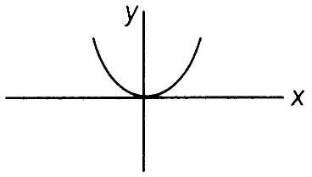

**OPTION B :** 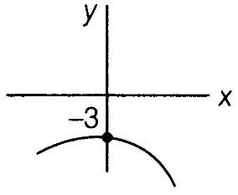

**OPTION C :** 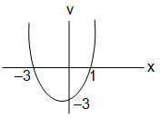

**OPTION D :** 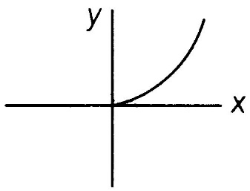

**CORRECT_OPTION :** 3

**SOLUTION :**

**CORRECT_ANSWER_FROM :**

**CORRECT_ANSWER_TO :**